Project Report – Event Registration App in Salesforce

# Phase 2 – Organization Setup and Configuration

## Objective

Establish a Salesforce environment where the Event Registration App can be developed and deployed.

## Tasks Performed

* Created Salesforce Developer Org and configured company profile.
* Created user roles: Administrator, Organizer, Attendee.
* Configured profiles and permissions for each role.

**Create Custom Objects in Salesforce**

* Custom Objects are like **tables in a database**. Each object stores records (rows), and each record has fields (columns).
* We’ll create **4 objects**:
* **Event__c**
* **Attendee__c**
* **Registration__c**
* **Feedback__c**

**Steps to create custom Object**

* Go to ⚙️ Setup (Gear Icon in top-right) → Object Manager.
* Click Create → Custom Object.
* Fill in:
* Label: Name of the object (e.g., Event).
* Plural Label: Events.
* Object Name: Salesforce will suggest Event__c automatically.
* Record Name: Keep as “Name” (Text type).
* Optional Settings → check:
  + "Allow Reports"
  + "Allow Activities"
  + "Track Field History"
* Click Save.

## Outcome

Salesforce environment was set up with role-based access ensuring correct permissions for admins, organizers, and attendees

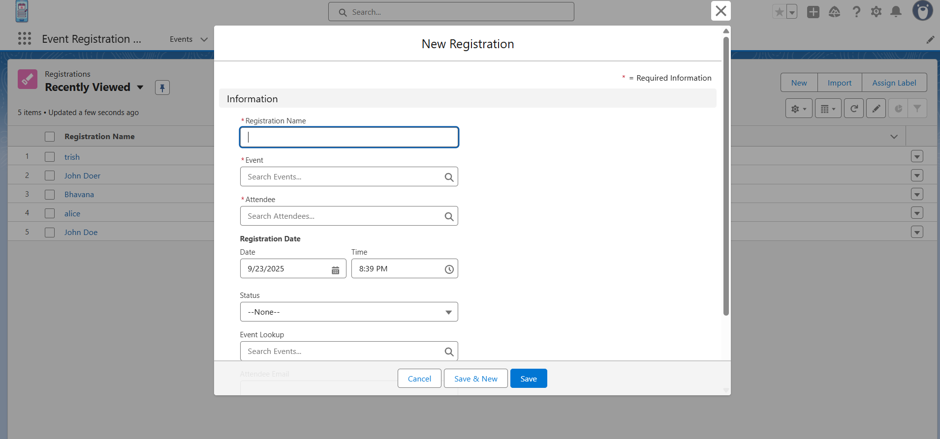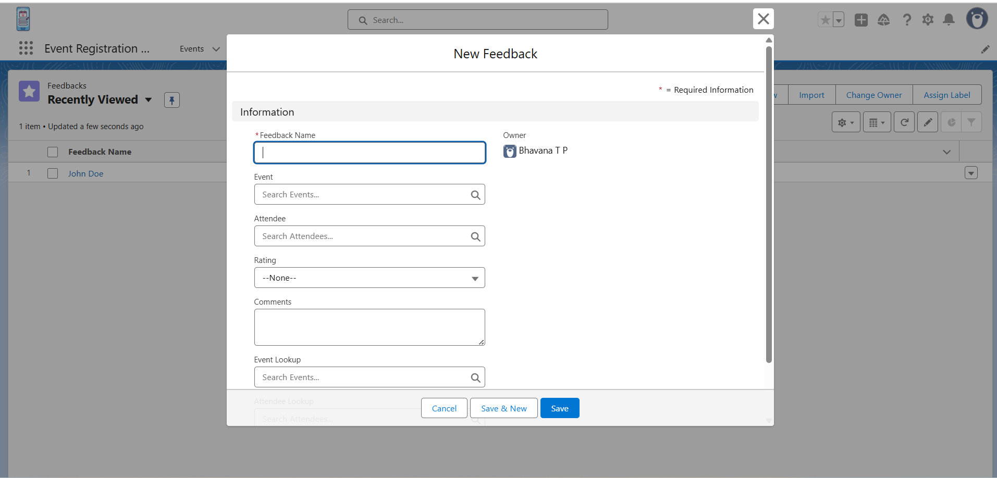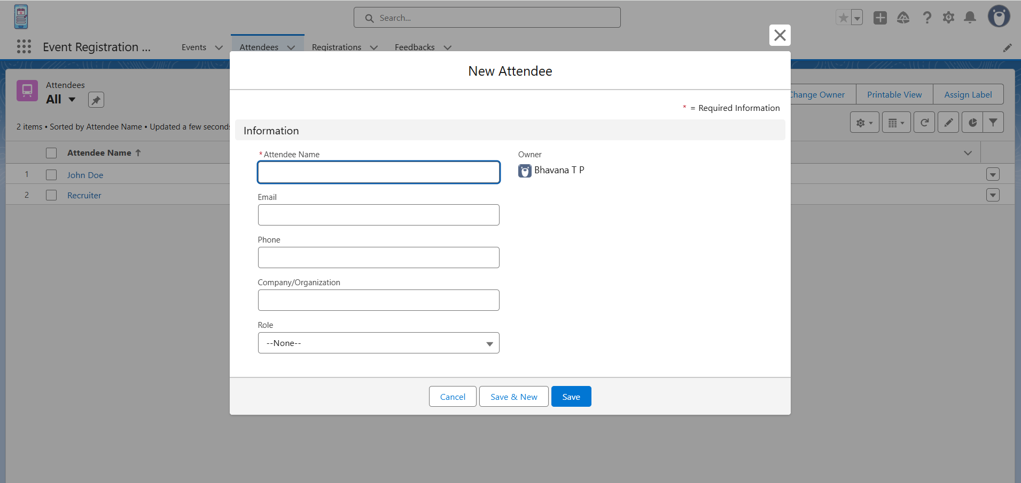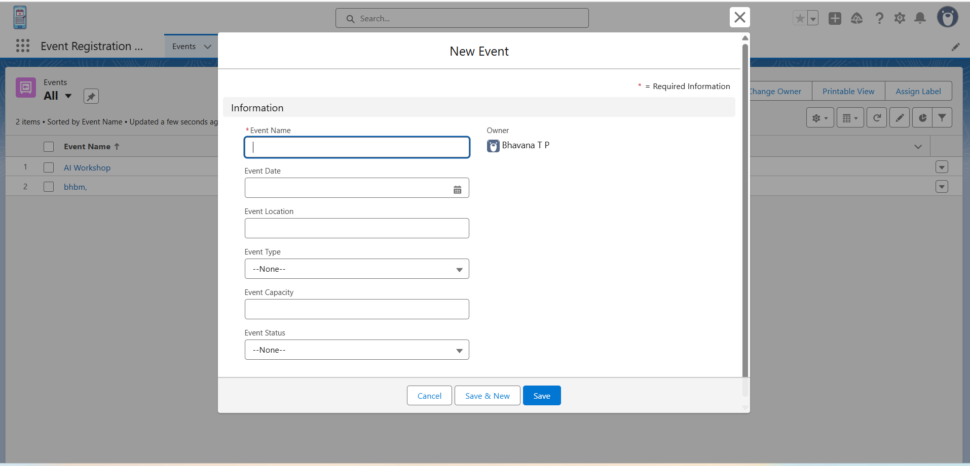

# Phase 3 – Data Modeling and Relationship

## Objective

Design a scalable and normalized data structure to support event registration, attendee management, and feedback collection.

## Tasks Performed

* - Created custom objects: Event__c, Attendee__c, Registration__c, Feedback__c.
* - Added key fields such as Event Name, Event Date, Event Capacity, Attendee Email, Registration Status, Feedback Rating.
* - Defined relationships: Event ↔ Registration, Attendee ↔ Registration, Event ↔ Feedback, Attendee ↔ Feedback.

**Define Relationships**

* **Event__c ↔ Registration__c** (1-to-Many: one event, many registrations).
* **Attendee__c ↔ Registration__c** (1-to-Many: one attendee can register for many events).
* **Feedback__c** linked to both Event__c and Attendee__c.

1. **Event ↔ Registration**

* One Event can have many Registrations (1-to-Many).
* How to Create:
  + Go to Object Manager → Registration__c → Fields & Relationships → New.
  + Choose Lookup Relationship.
  + Related To = Event__c.
  + Field Label = “Event”.
  + Save.

1. **Attendee ↔ Registration**

* One Attendee can register for many Events.
* How to Create:
  + Object Manager → Registration__c.
  + Create a Lookup Relationship to Attendee__c.
  + Field Label = “Attendee”.

1. **Event ↔ Feedback**

* One Event can have many Feedback entries.
* How to Create:
  + Object Manager → Feedback__c.
  + Create a Lookup Relationship to Event__c.
  + Field Label = “Event”.

1. **Attendee ↔ Feedback**

* One Attendee can give feedback for many Events.
* How to Create:
  + Object Manager → Feedback__c.
  + Create a Lookup Relationship to Attendee__c.
  + Field Label = “Attendee”.

**Build Page Layouts & Tabs**

1. For each object → **Page Layout** (drag and drop fields).
2. **Create Tabs** for Event, Attendee, Registration, Feedback (so they appear in App Launcher).
3. 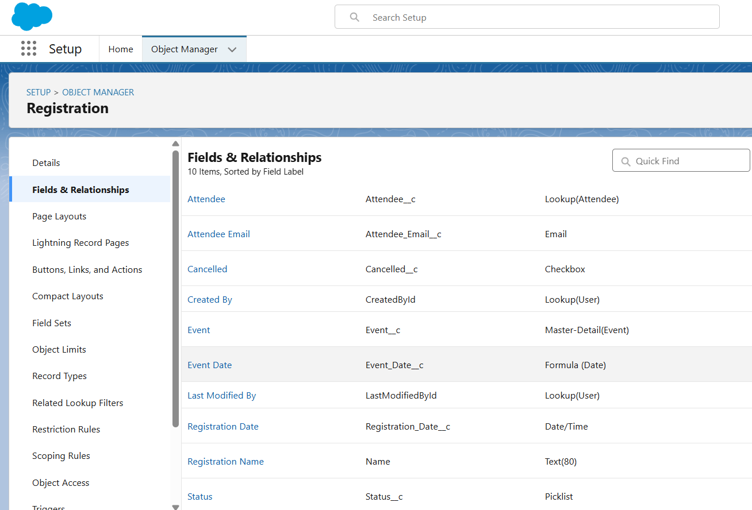Group them in a new **App (Event** Registration **App)**.

# Phase 4 – Process Automation (Admin)

## Objective

Automate repetitive processes such as confirmations, reminders, and validations.

## Tasks Performed

* - Built Record-Triggered Flow to send confirmation email when a registration is created.
* - Built Scheduled Flow to send reminder emails 1 day before Event Date.
* - Created Validation Rule to prevent overbooking.
* - Created Flow to auto-update Registration status when cancelled.

## Outcome

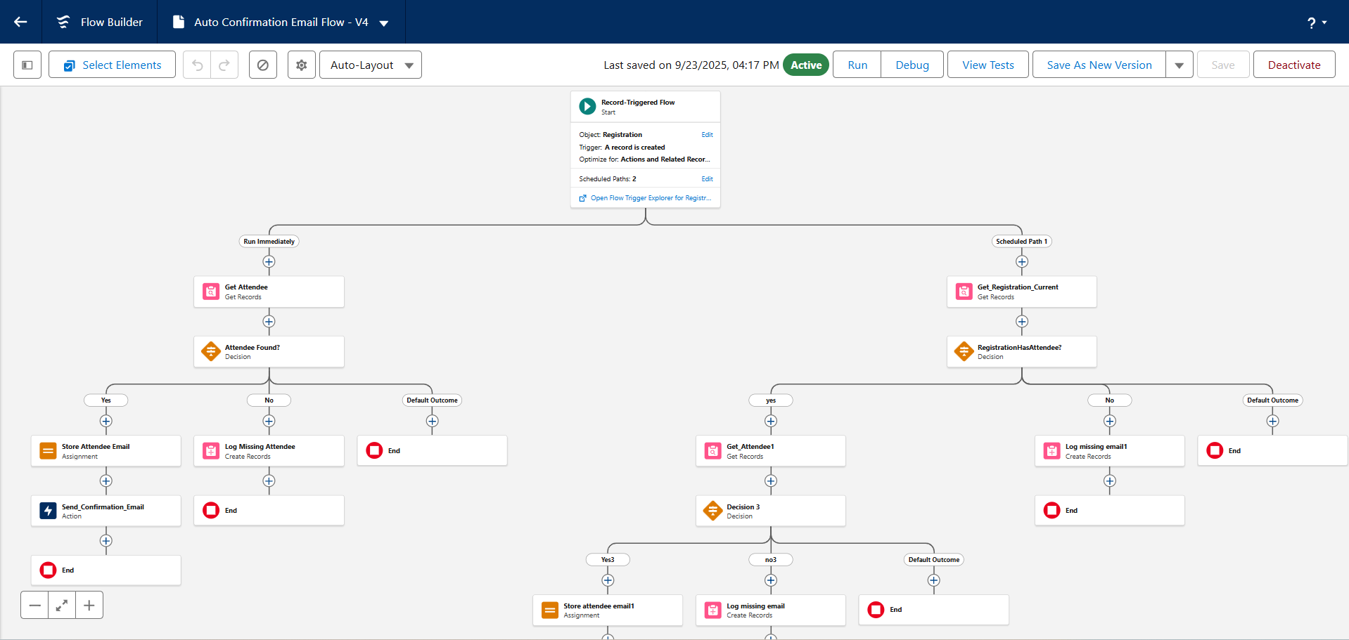Automation ensured timely communication, reduced manual work, and maintained data accuracy.

# Phase 5 – Apex Programming (Developer)

## Objective

Implement advanced business logic beyond declarative tools.

## Tasks Performed

* - Created RegistrationTrigger to auto-waitlist attendees if Event capacity is reached.
* - Created RegistrationAfterInsert trigger to call Apex class for confirmation emails.
* - Developed RegistrationHandler class to send programmatic emails.
* - Created EventAfterUpdate trigger to auto-create Feedback records once Event is marked completed.

## Outcome

Apex logic ensured robust, scalable automation and advanced event handling.

**Trigger: Prevent Overbooking & Auto-Waitlist**

trigger RegistrationTrigger on Registration__c (before insert, before update) {

// Collect Event IDs from incoming registrations

Set<Id> eventIds = new Set<Id>();

for (Registration__c reg : Trigger.new) {

if (reg.Event__c != null) {

eventIds.add(reg.Event__c);

}

}

// Query Events with their current registration count

Map<Id, Event__c> eventMap = new Map<Id, Event__c>(

[SELECT Id, Name, Capacity__c,

(SELECT Id FROM Registrations__r)

FROM Event__c

WHERE Id IN :eventIds]

);

// Apply logic

for (Registration__c reg : Trigger.new) {

if (reg.Event__c != null && eventMap.containsKey(reg.Event__c)) {

Event__c ev = eventMap.get(reg.Event__c);

Integer currentCount = ev.Registrations__r.size();

if (currentCount >= ev.Capacity__c) {

// Event is full → auto waitlist

reg.Status__c = 'Waitlisted';

} else {

// Seats available → mark registered

reg.Status__c = 'Registered';

}

}

}

}

**Trigger: Call Email Logic After Insert**

trigger RegistrationAfterInsert on Registration__c (after insert) {

for (Registration__c reg : Trigger.new) {

if (reg.Status__c == 'Registered') {

RegistrationHandler.sendConfirmationEmail(reg);

}

}

}

**Apex Class: Send Confirmation Email**

public class RegistrationHandler {

public static void sendConfirmationEmail(Registration__c reg) {

if (reg.Attendee__c == null || reg.Event__c == null) return;

// Fetch Attendee and Event details

Attendee__c att = [SELECT Id, Name, Email__c FROM Attendee__c WHERE Id = :reg.Attendee__c LIMIT 1];

Event__c ev = [SELECT Id, Name, Event_Date__c, Event_Location__c FROM Event__c WHERE Id = :reg.Event__c LIMIT 1];

// Construct email

Messaging.SingleEmailMessage email = new Messaging.SingleEmailMessage();

email.setToAddresses(new String[] {att.Email__c});

email.setSubject('Registration Confirmed: ' + ev.Name);

email.setPlainTextBody(

'Hi ' + att.Name + ',\n\n' +

'Your registration for "' + ev.Name + '" is confirmed.\n\n' +

'Date: ' + String.valueOf(ev.Event_Date__c) + '\n' +

'Location: ' + ev.Event_Location__c + '\n\n' +

'See you there!\nEvent Team'

);

Messaging.sendEmail(new Messaging.SingleEmailMessage[] {email});

}

}

**Trigger: Call Email Logic After Insert**

trigger RegistrationAfterInsert on Registration__c (after insert) {

for (Registration__c reg : Trigger.new) {

if (reg.Status__c == 'Registered') {

RegistrationHandler.sendConfirmationEmail(reg);

}

}

}

# Phase 6 – User Interface Development

## Objective

Provide a user-friendly interface for managing Events, Attendees, Registrations, and Feedback.

## Tasks Performed

* - Built Lightning App 'Event Registration App' with tabs for all objects.
* - Customized Page Layouts with relevant fields and related lists.
* - Configured Lightning Record Pages with dynamic components.

## Outcome

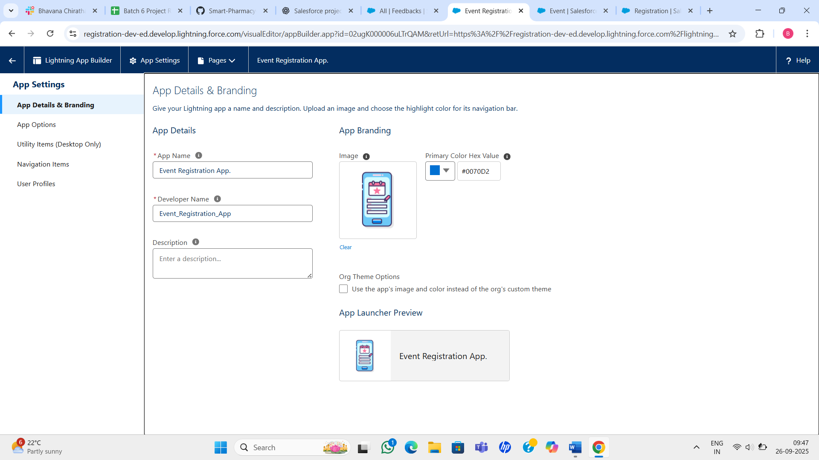Delivered an intuitive UI for admins and organizers to manage the event lifecycle.

# Phase 7 – Integration and External Access

## Objective

Allow external participants to interact with the system and provide communication tools.

## Tasks Performed

* - Configured Salesforce Experience Cloud site for external attendees.
* - Enabled Salesforce Email integration for organizer communication.

## Outcome

External users could self-register and organizers could communicate seamlessly.

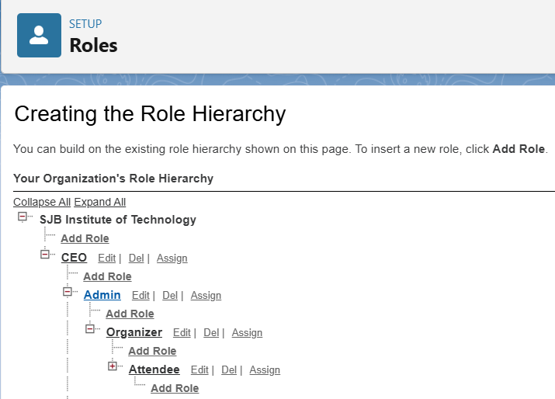

# Phase 8 – Data Management and Deployment

## Objective

Ensure clean data handling and successful deployment.

## Tasks Performed

* - Imported sample Events and Attendees via Data Import Wizard.
* - Validated mandatory fields and consistent relationships.
* - Deployed app configurations using Change Sets.
* - Created data backup and cleanup strategy.

## Outcome

Successful deployment with clean data and reliable processes.

**Phase 9 – Reporting, Dashboards, and Security Review**

**1. Reports**

**A) Report: Registrations by Event**

1. Go to **App Launcher → Reports → New Report**.
2. Choose **Report Type = Registrations with Events** (so you can group by Event).
3. In the outline:
   * Add **Event Name**.
   * Add **Registration ID or Attendee Name**.
4. In the **Group Rows**, drag **Event Name**.
5. Save report as Registrations by Event.

**B) Report: Attendees grouped by Registration Status**

1. **New Report** → Select **Registrations with Attendees**.
2. Add **Attendee Name** and **Status** fields.
3. Group rows by **Status**.
4. Optionally add **Row Count** to see totals per status.
5. Save as Attendees by Registration Status.

**C) Report: Feedback Ratings summarized per Event**

1. **New Report** → Choose **Feedback with Events**.
2. Add fields: **Event Name, Rating, Comments**.
3. Group rows by **Event Name**.
4. Add a **Summary** on the Rating field → choose **Average**.
5. Save as Feedback Ratings per Event.

**2. Dashboards**

Now, let’s visualize the reports in a dashboard.

1. Go to **Dashboards → New Dashboard**.
   * Name = Event Registration Dashboard.
   * Folder = Public Dashboards (or your folder).
2. Add components:

* **Pie Chart:**
  + Data Source = Attendees by Registration Status report.
  + Show distribution of statuses (Registered vs Cancelled vs Waitlisted).
* **Bar Chart:**
  + Data Source = Feedback Ratings per Event.
  + X-axis = Event Name.
  + Y-axis = Average Rating.
* **Line Chart:**
  + Data Source = Registrations by Event.
  + Group by Event Date (or Created Date of Registration).
  + Show trend of registrations over time.

1. Save and run the dashboard.

**3. Security Review**

**A) Organization-Wide Defaults (OWD)**

1. Setup → **Sharing Settings**.
2. Under OWD:
   * **Event__c** = Public Read/Write (organizers can collaborate).
   * **Registration__c** = Private (only owners see their records).
   * **Attendee__c** = Private.
   * **Feedback__c** = Controlled by Parent (or Private).
3. Save.

**B) Role Hierarchy**

1. Setup → **Roles → Set Up Roles**.
2. Create hierarchy:
   * Top: Admin.
   * Below: Organizer.
   * Below: Attendee.
3. Assign users to roles.

**C) Sharing Rules**

1. Setup → **Sharing Rules**.
2. Example: For **Registration__c**, create a rule:
   * Share records owned by Attendee role with Organizer role → Read/Write.

**D) Field-Level Security**

1. Setup → **Object Manager → Attendee__c → Fields & Relationships**.
2. Open **Email__c** field → click **Set Field-Level Security**.
3. Uncheck visibility for profiles that should not see attendee emails (e.g., Attendee profile).
4. Save.

